

**SCHOOL OF ENGINEERING & TECHNOLOGY**

**DEPARTMENT OF COMPUTER SCIENCE & INFORMATION**

**DESIGN AND IMPLEMENTATION OF A COMMUNITY-BASED LOCAL SERVICES AND AMENITIES LOCATOR APP**

**A PROJECT SUBMITTED IN PARTIAL FULFILLMENT OF THE REQUIREMENT FOR THE DEGREE OF BACHELOR OF SCIENCE (BSC.) IN COMPUTER SCIENCE**

**DANIEL ADDOTEY ALLOTEY & MUNIRU MOHAMMED**

**CSC/21/01/1399 CSC/21/01/**

DATE, 2025

**DECLARATION**

**Student’s Declaration**

We hereby declare that this project work is the result of our own original research and that none of it has been presented for another degree in this University or elsewhere. We are responsible for any errors and omissions detected.

**Signature: __________________ Signature: __________________**

**Name: __________________ Name: __________________**

**Date: ___________________ Date: ___________________**

**Supervisor’s Declaration**

I hereby declare that the preparation of the project work was supervised in accordance to the guidelines of supervision of project work laid by Central University.

**Supervisor’s Signature: __________________**

**Name: _________________________________**

**Date: ___________________**

# 

# ACKNOWLEDGEMENT

All praises belong to God almighty, and thanks for this divine assistance and guidance, which made it possible for it to be possible for us to complete our academic program. We want to express our gratitude to all the people who helped complete our final year project work. Their support and encouragement have been priceless throughout the completion of our project work. We would also like to thank our project supervisor Mr. Frederick Gardiner for his guidance and assistance. His expertise and mentorship have played a huge role in enhancing the quality of our project. We are also grateful for his support and the opportunities he provided us for our professional growth. We are grateful for our family’s love and encouragement throughout our academic journey. Finally, to all who played a role and made this project a success, we are very grateful for all your support and contributions.

# 

# ABSTRACT

The automatic control system is to detect, alert and fight liquefied petroleum gas fires at gas sales stations. This system will automatically suppress and fight any fire that would occur at gas sales stations.

The main reason for developing this automatic fire fighting control system is to quickly, effectively and efficiently release stored water to suppress and fight fires at the liquefied petroleum gas sales stations (gas distribution units). Subsequently, this system will reduce the over reliance on fire fighters, property losses, human injuries and deaths as well as environmental destruction. This system will consist of three key parts and which are, Gas Leakage Detection Systems, Addressable Fire Alarm System and the Fire Suppression System. Design and development of this system rely on calculations to determine the water tank capacity, tank installation height to provide useful water flow head and various parts layout for connections.

**TABLE OF CONTENTS**

1. CHAPTER 1 ----------------------------------------------------------------------------- 8

INTRODUCTION ----------------------------------------------------------------------- 8

* 1. BACKGROUND OF STUDY ---------------------------------------------------- 8
  2. PROBLEM STATEMENT -------------------------------------------------------- 8
  3. AIM AND OBJECTIVES ---------------------------------------------------------- 9
  4. IMPORTANCE OF THIS PROJECT------------------------------------------- 9
  5. THE PROJECT SCOPE OF WORKS----------------------------------------- 9
  6. LIMITATIONS ----------------------------------------------------------------------- 9

1. CHAPTER 2 ----------------------------------------------------------------------------- 10

LITERATURE REVIEW --------------------------------------------------------------- 10

* 1. INTRODUCTION -------------------------------------------------------------------10
  2. GAS EXPLOSIONS AND FIRES IN ACCRA AND KUMASI-------------10
  3. CHALLENGES RESEARCH -----------------------------------------------------11

1. CHAPTER 3 ------------------------------------------------------------------------------ 12

DESCRIPTION, CHALLENGES AND SYSTEM REVIEW ---------------------12

* 1. DESCRIPTION OF EXISTING SYSTEM ------------------------------------- 12
  2. CHALLENGES OF THE EXISTING SYSTEMS ----------------------------- 12
  3. REVIEW OF THE EXISTING SYSTEMS -------------------------------------- 12
  4. ADVANTAGES OF THE PROPOSED SYSTEM ---------------------------- 13

**4** CHAPTER 4 ----------------------------------------------------------------------------------- 14

METHODOLOGY ---------------------------------------------------------------------------- 14

4.1 INTRODUCTION ------------------------------------------------------------------------ 14

4.1.1 DATA COLLECTION METHODS ---------------------------------------------- 14

4.1.2 DATA ANALYSIS ------------------------------------------------------------------ 15

4.1.3 CONCLUSION ---------------------------------------------------------------------- 17

4.2 DESIGN MODEL AND CALCULATIONS ------------------------------------------ 17

4.2.1 INSTALLATION OF THE SYSTEM ------------------------------------------- 18

4.2.2 OPERATION PRINCIPLE OF THE SYSTEM ------------------------------ 18

4.2.3 SYSTEM MODEL FOR WIRING INSTALLATION ------------------------ 18

4.2.4 WATER STORAGE TANK CAPACITY DETERMINATION ------------- 19

4.2.5 WATER TANK AND PLATFORM SIZE DETERMINATION ------------- 20

4.3 LOGICAL DESIGN ----------------------------------------------------------------------- 21

4.4 ALGORITHM ------------------------------------------------------------------------------ 22

4.5 SIMULATION ------------------------------------------------------------------------------ 23

4.6 SUMMARY --------------------------------------------------------------------------------- 28

**5** CHAPTER 5

SUMMARY, CONCLUSION AND RECOMMENDATION ----------------------------- 29

5.1 SUMMARY ---------------------------------------------------------------------------------- 29

5.2 CONCLUSION ----------------------------------------------------------------------------- 30

5.3 RECOMMENDATION -------------------------------------------------------------------- 30

**LIST OF FIGURES**

FIGURE 1 GAS EXPLOSION AT LOUIS GAS STATION ------------------------------- 15

FIGURE 2 GAS EXPLOSION AT ATOMIC JUNCTION --------------------------------- 15

FIGURE 3 DESIGN MODEL -------------------------------------------------------------------- 17

FIGURE 4 INSTALLATION DESIGN --------------------------------------------------------- 19

FIGURE 5 WATER TANK ----------------------------------------------------------------------- 20

FIGURE 6 ELECTRICAL LOGIC CIRCUIT ------------------------------------------------- 22

FIGURE 7 MESH END VIEW ------------------------------------------------------------------ 23

FIGURE 8 MESH FRONT VIEW -------------------------------------------------------------- 23

FIGURE 9 SOLID END VIEW ------------------------------------------------------------------ 24

FIGURE 10 SOLID FRONT VIEW ------------------------------------------------------------ 24

FIGURE 11 ADDRESSABLE FIRE ALARM ------------------------------------------------ 25

FIGURE 12 ELECTRICAL COONECTIONS ----------------------------------------------- 25

FIGURE 13 GAS DEPOT SIDE VIEW 1 ----------------------------------------------------- 26

FIGURE 14 GAS DEPOT SIDE VIEW 2 ----------------------------------------------------- 26

FIGURE 15 GAS STORAGE TANK VIEW -------------------------------------------------- 27

FIGURE 16 WATER TANK VIEW ------------------------------------------------------------- 27

FIGURE 17 GAS SALES STATION ----------------------------------------------------------- 28

**LIST OF TABLES**

TABLE 1 DETAILS OF GATHERED NON-NUMERICAL DATA -------------------- 14

TABLE 2 ANALYSIS AND EVALUATION ------------------------------------------------ 16

TABLE 3 TRUTH TABLE ---------------------------------------------------------------------- 21

**CHAPTER 1**

**Introduction**

**1.1 BACKGROUND OF STUDY**

Propane and Butane are nontoxic flammable gases which have been mixed and liquefied under extreme pressure in a Metal Container or Tank or Cylinder is called Liquefied Petroleum Gas (LPG). The LPG is very sensitive to fire and can cause a great disaster if it is exposed to any fire source without precaution. Indeed, LPG is highly inflammable and can catch fire easily even at a distance from the source of leakage. Leakage of the LP gas may lead to an explosion and probably causing fire which might result in loss of human lives, damaging of properties and consequently inflicting injuries to the human bodies. The LPG is very economical to use and therefore it is widely used for cooking and the running of motor vehicle engines, especially. In Ghana, the Liquefied Petroleum Gas is always stored in Large Steel Surface Tanks at the sales stations (depots) for distribution to large number of consumers. The locations of some of these sales stations (depots) are close to human populated areas. Frequently, the Liquefied Petroleum Gas occupies the close surroundings of the customer’s cylinders that are being filled at the sales point and therefore any spontaneous metal sparks or exposed fire source within this vicinity will set the sales station, surrounding houses, customers and facility operators ablaze hence causing a great disaster. Any LPG cylinder that is involved in a fire may overheat and then rupture violently posing another great danger to human beings within that close vicinity. Similarly, gas leaking from piping or tank cannot escape this disaster if fire source is available. Mostly, gas leakages may result from the use of sub-standard cylinders, damaged old valves, no regular checking of gas cylinders, worn out regulators and improper handling of the gas cylinders.

As the Liquefied Petroleum Gas consumption in the communities grows, many gas cylinders, large number of human population and many vehicles would then be choking the gas sales station to purchase gas. In the event of panic buying, the sales stations would be largely populated and consequently, due to forgetfulness, misunderstanding, short cuts and violations (non-complaint) from Liquefied Petroleum Gas handling stipulated laws and regulations there is the likelihood of human errors taking place which can cause fire**.**

**1.2 PROBLEM STATEMENT**

There have been cases where fires that occurred at the LPG sales station were not addressed instantly hence destroying properties and taking human lives. There have also been cases where fire fighters were at the fire scene but unfortunately, were not having enough water to fight the raging fire and these fires eventually destroy properties and human lives. At certain times too, water do not flow through the fire hydrants for use to fight these fires. Surprisingly, some of the fire hydrants have been blocked by building structures hence making them inoperable. In view of these disappointing behaviors, the dependence on fire fighters and the fire hydrants to combat fires here in Ghana is often dangerous and disappointing. Undeniably, time is a key factor when it comes to fire-fighting. The earlier the detection and suppression of fires, the faster the fires can be put out. Therefore, there is the need for an automatic system to detect, alert and fight any fires that occur at the LPG sales station.

**1.3 AIMS AND OBJECTIVES**

The aim of this project is to design and introduce a cost-effective automatic control system to detect, alert and fight LPG fire at gas sales stations.

The key objectives of this system are

* Detection of any possible fire at the LPG sale station
* Alerting customers and sales attendants of the possible fire for them to escape
* Fighting fire quickly with water

**1.4 IMPORTANCE OF THIS PROJECT**

Automation has the capacity to monitor, regulate and respond to commands and devices faster than humans. This project is highly important because it reduces human delay, replaces human absence hence reliable. It regulates the behavior of other components within the circuit to achieve a desired output or performance. The design and introduction of the automatic fire prevention and fighting system will satisfactorily detect, alert and fight LPG fire at gas sales stations.

**1.5 THE PROJECT SCOPE OF WORKS**

Activities that shall be employed to design the Automatic Fire Prevention and Fighting System to detect, a2lert and fight LPG fire at gas sales stations, involve:

* Listing of devices that will form the automatic control system.
* Designing the system model of the control system’s devices layout.
* Designing of circuit diagram for the control system’s devices connections.
* Calculations to determine and select the required fire sprinkler type according to the standards of National Fire Protection Association (NFPA).
* Calculations to determine the water tank capacity.
* Calculations to determine the water tank head.

**1.6 LIMITATIONS**

This project design is limited to the Liquefied Petroleum Gas sales stations only.

**CHAPTER 2**

**LITERATURE REVIEW**

**2.1 INTRODUCTION**

This chapter deals with the review of related literature considered underrecent years’ gas explosions and fires which occurred in Ghana claiming many human lives and caused several severe injuries with damages to several properties.

**2.2** **GAS EXPLOSIONS AND FIRES IN ACCRA AND KUMASI**

Typical places among others which sustained these explosions and fires are the:

2.2.1 Louis Gas Station behind the Trade Fair Centre at Labadi in Accra. The Fire Service personnel desperately tried to put out this fire but unfortunately the three fire tenders that were sent by these fire service officers were inadequate and therefore ran out of water. The fire service personnel then went to refill the Tanks of their fire Tenders while this fire was still raging further. The fire which resulted from the LPG explosion was reported to have burnt six human bodies beyond recognition (Dec 22, 2016). Two Bolts which should have "tightened the lid" of the Gas Tanker were missing. When the Liquid Petroleum Gas (LPG) was being discharged from the Gas Tanker into the Bulk Storage Tank, pressure built up within the Gas Tanker vessel and force the lid open because of the missing two bolts. The lid came out like a missile and spewed out 200 meters LPG into the Labadi Trade Fair site and caused the fire [1].

2.2.2 Atomic Junction in Madina, Accra, where a Petrol Tanker belonging to the Ghana Oil Company (GOIL) caught fire while off-loading fuel into the underground tanks at the filling station. This fire which promptly radiated towards an LPG depot situated next door resulted in a large-scale explosion at the site of the Liquefied Petroleum Gas station and consequently caused the death of seven people with about one hundred and thirty-two people sustaining various injuries. Fire service personnel found it difficult to put these fires under control [2].

* + 1. ENGAS Filling Station at Asokwa, a suburb of Kumasi, resulted in the death of three persons and causing injuries to many other people while massive properties were destroyed [3].
  1. **THE RESEARCH**

Qualitative Research Methodology type was used and which identified online related articles revealing a number of existing knowledges around the LPG explosions and fires at the filling stations and these are:

### An average of 250,000 metric tons of LPG was supplied to the Ghanaian market annually.This was distributed through 593 LPG refilling plants around the ten regions of Ghana. It was precipitated that an average of 422 metric tons was supplied by each LPG refilling plant annually [4].

### Transportation of LP-GAS from the Bulk Distribution Companies (BDC depot) to refilling plants for customers to refill their empty LPG cylinders and non-adherence to safety standards led to several incidents claiming lives and properties [5].

### Handlers of the LPG at the refilling plants do not undergo regular safety training or skills upgrade to ensure adherence and compliance with safety procedures [6].

### Handlers and managers of the LPG do not have access to reliable equipment that will enable them detect LPG leakage promptly [7].

**CHAPTER THREE**

**DESCRIPTION, CHALLENGES AND SYSTEMS REVIEW**

# DESCRIPTION OF EXISTING SYSTEMS

# In our research, similar systems were found to have been designed and these are:

* Design of a wireless LPG monitoring system was proposed by K. Padmapriya et al. In this design, the user is alerted about the gas leakage through SMS and the power supply is turned off. [8]
* Design of leakage detection and real time gas monitoring system was proposed by Meenakshi Vidya et al. In this system, the gas leakage is detected and controlled by means of an exhaust fan while the level of LPG in cylinder is also continuously monitored. [9]
* Design of a system in which the leakage is detected by the gas sensor and produce the results in the audio and visual forms was proposed by Selvapriya et al. This design involves both software as well as hardware. Different gas sensing technology is used for this design method. [10]

**3.2 CHALLENGES OF THE EXISTING SYSTEMS**

The existing systems were comprehensively analyzed and challenges that were detected are:

Any fire that would arise cannot be put off because the systems rely solely on electric power supply to function and which is quickly shut off in any case of fire. It is therefore safe to say that these designs cannot be reliable to fight fires at the LPG sales stations.

* The proposed design systems can either alert person around and inside the LPG stations of fire danger to quickly vacate the vicinity while the alerts would make the sales attendants to quickly fight the fire while the fire service is called for reinforcement to put off this fire manually.
* The proposed designs lack the incorporation of automatic fire extinguishing sensor device as well as large volume of water stored in an overhead storage tank for use as and when required to fight fire.
  1. **REVIEW OF THE EXISTING SYSTEMS**

In view of the challenges identified in the existing systems, this project therefore proposes to introduce **a cost-effective automatic control system** designed to contain embedded sensors to detect any gas leakage, raise any fire alarm and quickly suppress Liquefied Petroleum Gas Fire that might have started at the gas sales station. This embedded control and monitoring system consists of three main sensitive parts and these are:

* Gas Leakage Detection Systems (focuses accurately and sensitively on the gas flow lines to timely reveal any leakage for response with the help of an addressable fire alarm system).
* Alert Systems Powered by Solar Energy (focuses on gas leakage detected communication received to quickly sound an audible alarm to create hazardous awareness to everybody within the vicinity)
* Fire Suppression Systems (integrated sensors and actuators activating fire sprinklers to rapidly and accurately suppress any fire that might spontaneously start as a result of the gas leakage).

Evidently, since large volume of water and every other fire-fighting medium is required to be sprayed unabated, it is therefore reviewed that a high volume of water tank shall be designed to store a quantity of water equivalent to about 25,200 Liters (5,600 gallons) to quickly put off fires. This volume of water shall be enough to avoid the station from running out water. A gravity water flow system shall be used to discharge this water from overhead tank without the use of an electric pump.

* 1. **ADVANTAGES OF THE PROPOSED SYSTEM**

This cost-effective automatic control system would help detect and fight fires at its early stages to prevent it from escalating. This cost –effective automatic control system would provide the following benefits:

* Early detection of smoke and fires
* Suppression of smoke and fires
* Sends warning signals
* Reliable power source
* Locates the exact place of trouble
* Easy installation
* Functions even without water pump
* Solar energy powered
* Very sensitive to change in temperature

**CHAPTER FOUR**

**METHODOLOGY**

**4.1 INTRODUCTION**

This project work is strictly a case study of the Gas Explosions and Fires at Louis Gas Station behind the Trade Fair Centre at Labadi in Accra, Atomic Junction in Madina, Accra on Petrol Tanker belonging to the Ghana Oil Company (GOIL) and Engas Filling Station at Asokwa, a suburb of Kumasi.

Qualitative Research Methodology type was therefore employed for data gathering for analysis and development.

**4.1.1 DATA COLLECTION METHODS**

Non-numerical data were uniquely gathered from online Radio news and Television images about these Gas Explosions and Fires cases. Non-numerical data whose details are shown in Table 1, were gathered on the Gas Explosions and Fires cases.

Table 1 Details of gathered Non-Numerical Data

|  |  |  |
| --- | --- | --- |
| **Gas Explosions and Fire Disasters** | **Details of Data as Reported** | **Data Source** |
| Louis Gas Station behind the Trade Fair Centre at Labadi in Accra. | Two Bolts which should have "tightened the lid" of the Gas Tanker were missing. When the LPG was being discharged from the Gas Tanker into the Bulk Storage Tank, pressure built up within the Gas Tanker vessel and forced the lid to open because of the missing two bolts. The lid came out like a missile and spewed out LPG through a distance of 200 meters into the Labadi Trade Fair site and caused the fire. Six human bodies were reported to have burnt beyond recognition. | Joy FM Radio station by the National Petroleum Authority (NPA) Head, Moses Asaga. |
| Petrol Tanker belonging to the Ghana Oil Company (GOIL) at Atomic Junction in Madina, Accra. | The Petrol Tanker caught fire while off-loading fuel into the underground tanks at the filling station. The fire promptly radiated towards an LPG depot situated next door and resulted in a large-scale explosion causing the death of seven people with about one hundred and thirty-two people sustaining various injuries. Fire service personnel found it difficult to put these fires under control. | Ganaweb |
| Engas Filling Station at Asokwa, a suburb of Kumasi. | ENGAS Filling Station accidentally caught fire while taking delivery of fresh gas stocks and resulted in the death of three persons and caused injuries to many other people while massive properties were destroyed. | Myjoyonline news |

**4.1.2 DATA ANALYSIS**

This study has the objective of critically observing images of impacts caused by these disasters (as shown in Figures 1 and 2). In order to gain an in-depth understanding of the causes of these fatal and very destructive explosions and fires for a complete preventive solution search, details of thegathered data and images on the disasters were deeply analyzed and evaluated using Qualitative data evaluation process.

**The trend of these three disasters which occurred at** different locations **as** shown in Table 2 has **therefore revealed that** Human error and lack of safety measures application were the main cause of the disasters.

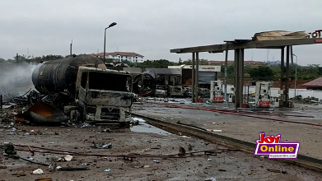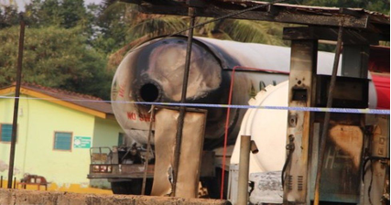

Figure 1 Figure 2

Figure 1 is the state of the gas explosion that occurred at the Louis Gas station at labadi whereas figure 2 is the explosion that occurred at Atomic junction in madina.

**Table 2 Analysis and Evaluation**

|  |  |  |  |
| --- | --- | --- | --- |
| **Gas Explosions and Fire Disasters** | **Details of Data as Reported** | **Analysis** | **Findings** |
| Louis Gas Station behind the Trade Fair Centre at Labadi in Accra. | Two Bolts which should have "tightened the lid" of the Gas Tanker were missing. When the LPG was being discharged from the Gas Tanker into the Bulk Storage Tank, pressure built up within the Gas Tanker vessel and forced the lid to open and came out like a missile and spewed out LPG through a distance of 200 meters causing the fire. | What made the “Two Bolts” which should have "tightened the lid" of the Gas Tanker to be missing?  Would it have helped put off the fire quickly if the LPG sales station was having an automatic fire fighting system? | Human error and lack of safety measures enforcement made the two missing bolts not replaced.  Yes.  No human life would have been lost and no property damage would have been lessened. |
| Petrol Tanker belonging to the Ghana Oil Company (GOIL) at Atomic Junction in Madina, Accra. | The Petrol Tanker caught fire while off-loading fuel into the underground tanks at the filling station. The fire promptly radiated towards an LPG depot situated next door and resulted in a large-scale explosion. | What caused the fire of Petrol Tanker while off-loading fuel into the underground tanks at the filling station?  Would the radiated fire towards an LPG depot situated next door have been prevented?  Would it have helped put off the fire quickly if the LPG sales station was having an automatic fire fighting system? | Human error and lack of safety measures enforcement.  Yes by strict safety measures enforcement.    Yes.  No human life would have been lost and neither such property damages too could have occurred. |
| Engas Filling Station at Asokwa, a suburb of Kumasi. | ENGAS Filling Station accidentally caught fire while taking delivery of fresh gas stocks and resulted in the death of three persons and caused injuries to many other people while massive properties were destroyed. | What caused the fire? | Human error and lack of safety measures enforcement.  The automatic fire fighting system would have helped and no human life would have been lost. |

**4.1.3 CONCLUSION**

**Based on the findings made after analyzing the gathered data and** images **(**Table 2, **Analysis and Evaluation), it can confidently be concluded that the three** Gas Explosions and Fire Disasters were caused by Human errors and lack of safety measures enforcement.

The results of this study were then used to develop a Model for the Automatic Fire Prevention and Fighting System.

**4.2 DESIGN MODEL AND CALCULATIONS**

The model in figure 3, has been developed to form the LPG Automatic Fire Prevention and Fighting System and consists of LPG Storage Tank, Overhead Water Tank, LPG Sales Station, Solar Panel, Addressable Fire Alarm Panel (Main Control Panel), Office and Wash Room.

Addressable Fire Alarm Panel (Main Control Panel)

LPG

Storage

Tank

Office room (washroom inclusive)

Transformers

Water

Pipe

Solar Panel

LPG Sales Station

Overhead Water Tank

-------------------------------------------------

Water Pipe Underground cable

Figure 3. Design Model

**4.2.1 INSTALLATION OF THE SYSTEM**

Galvanized Pipe of 25mm diameter shall be laid from the overhead water tank to metal frame structures to be erected above the LPG storage tank and Sales station respectively. The bottom part of these galvanized pipes which are above the LPG Storage Tank and Sales Station shall be connected with fire sprinklers, smoke and heat detectors not excluding the office and wash room. Signaling Line Circuits (SLC) shall be connected from the Solar Panel through the Addressable Fire Alarm Panel (Main Control Panel) on to these fire sprinklers, smoke and heat detectors. A number of sprinklers shall be connected at a determined spacing and each of these sprinklers shall have its own individual sprinkler head which shall activate independently only when it is directly exposed to the heat of the fire.

**4.2.2 OPERATION PRINCIPLE OF THE SYSTEM**

In the event of fire or explosion, smoke shall be detected by the smoke sensor which will quickly send its signal to cause sounding of the alarm. Unabatedly, the sprinkler head(s) which are directly exposed to the heat of the fire will cause the glass bulbs of these sprinklers to shatter and thereby causing the pressurized water in the pipeline to spray out forcefully through the sprinklers’ water plugs but evenly distributed to extinguish or suppress the fire within that vicinity and the surrounding areas. The fire sprinklers are also connected to the fire alarm system which triggers an alarm to alert people in the vicinity to escape. In order to avoid electric power outages (“dumsor”) to disrupt functioning of the system, electric power shall always be supplied from an erected solar panel. The Addressable Fire Alarm Panel (Main Control Panel) is the system’s monitoring device and which shall have the Alarm report to be displayed on its main control panel to pinpoint the exact location of the activated smoke detector.

**4.2.3 SYSTEM MODEL FOR WIRING INSTALATION**

* The arrangement of system is designed to work effectively. Sprinkler spacing is a field determination activity.
* The proper positioning, spacing and connections for the installation of the system for its effective functioning has been determined by the following calculations;

N

Heat detector

Smoke detector

Manual call point

L

Loop isolator

Heat detector

Smoke detector

Manual call point

Addressable fire alarm system

Buzzer (Alarm)

Power source (solar panel)

Figure 4. Installation design

* The installation model above describes the proper installation of the system. The black lines represent neutral wires whereas the orange lines represent live wires. Heat and smoke detectors would be connected under the shed of the sales point and the near the storage tank. These are the main areas where a fire can start. The sprinkler system would also be installed in the office of the sales station to fight any possible fire that might occur there.

**4.2.4 WATER STORAGE TANK CAPACITY DETERMINATION**

### Fire can quickly and successfully be extinguished when large volume of inexhaustible water is always available. Therefore, the volume of water to be stored in the Overhead Storage Tank at the LPG filling station was determined based on Ghana National Fire Service that 4,000 liters of water to be dispensed within a period of eight (8) minutes for firefighting depending on the fire intensity.

### Ideally in firefighting:

### If volume of water dispensed in 8 minutes = 4,000 Liters (888.89 gallons)

Let the length of time when all fires will have confidently been put off = 50.40 minutes.

Now, (50.40mins/8mins) x 4,000 Liters = 25,200 Liters of water (5600 gallons of water).

Hence, water storage capacity for the overhead tank is 25,200 Liters (5600 gallons).

**4.2.5 WATER TANK AND PLATFORM SIZE (FIG. 4) DETERMINATION**

The minimum water spraying pressure of any sprinkler should be 0.5bar, the National Fire Protection Association, Standard No. 13 (NFPA-13). Therefore, using gravity water flow system and the 0.5bar minimum water spray pressure, the water Storage Tank and Platform Sizes are determined as follows:

Now, P = ρɡh

Where:

P = pressure of water from water tank

ρ = density of water = 1000 Kg/m3

ɡ = acceleration due to gravity = 9.81m/s2

hp = head = height of Tank from ground to tank base (m)

Now, P = 0.5 bar = 0.5 x 105 N/m2, 1 bar = 105 N/m2

P = ρɡhp

0.5 x 105 N/m2 = 1000 x 9.81 x hp (Kg/m3 x m/s2), 1 Kgm/ s2 = 1N

hp = (0.5 x 105)/ (9810)

**hp = 5.10m**

Height (h) of Tank from ground to tank base is **5.10m**

Water tank

ht

water flow

platform hp

Figure 5. Water tank

**4.3 LOGICAL DESIGN**

The spread of flames, the presence of dense smoke, and the possibility of high temperatures are the components of fires. The flame sensor, the smoke sensor, and the temperature sensor are the three sensors that are able to detect the properties of these three elements, respectively. Only when two or more than two sensors identify an abnormal state will the circuit produce an alarm signal. This is done to ensure that the false alarm does not occur and interfere with people's day-to-day lives and to avoid the false alarm from an impact on people's lives. The possibility of two or more sensors giving the indication of possible fires is very high. Subsequently, if only one sensor gives the signal, it is likely faulty and needs maintenance or change. The combinational logic circuit in order to realize the normal operation of the circuits are primarily made up of gate circuits and medium-scale integrated chips found in the addressable fire alarm system. This is due to the fact that the circuit is formed of three primary input sensors. The truth table shows the combinational logic circuit for the operation.

=

**A(**input) **B (**input) **C(**input) **D(**output**)**

|  |  |  |  |
| --- | --- | --- | --- |
| 0 | 0 | 0 | 0 |
| 0 | 0 | 1 | 0 |
| 0 | 1 | 0 | 0 |
| 0 | 1 | 1 | 1 |
| 1 | 0 | 0 | 0 |
| 1 | 0 | 1 | 1 |
| 1 | 1 | 0 | 1 |
| 1 | 1 | 1 | 1 |

Table 3. Truth table

The table shows all the outcomes of both positive and negative events. D represents the outcomes of the combinational inputs. A, B and C respectively represents the heat detector, smoke detector and temperature detector of fire sprinklers. The input "1" indicates the presence of abnormalities, whereas the input "0" indicates that there are no abnormalities on the system. The output "1" indicates the development of an alarm signal, whereas the output "0" indicates that there is no generation of an alarm signal. These values are displayed in the table that is located above. The sum of products of the outputs is;

D =AB′C+ABC′+A′BC+ABC

Simplifying the above expression gives the solution D=AB+CA+CB



**A**

**B**

**D**

**C**

Figure 6. Electrical Logic Circuit

**4.4 ALGORITHM**

Step 1: Initialize heat sensor, smoke sensor, buzzer, and sprinkler system.

Step 2: Set predefined threshold values for heat and smoke sensors.

Step 3: If any one sensor reports an abnormality

Step 4: Do nothing

Step 5: If any 2 sensor reports an abnormality

Step 6: Activate the buzzer

Step 7: Manually activate sprinkler system if it hasn’t reported an abnormality yet.

Step 8: If all 3 sensors report abnormalities

Step 9: Go to step 6

Step 10: Else go to step 4

**4.5 SIMULATION**

The design of the Automatic Fire Prevention and Fighting System was simulated using the blender software. The figures and description below illustrate the buildup and layout of the system.

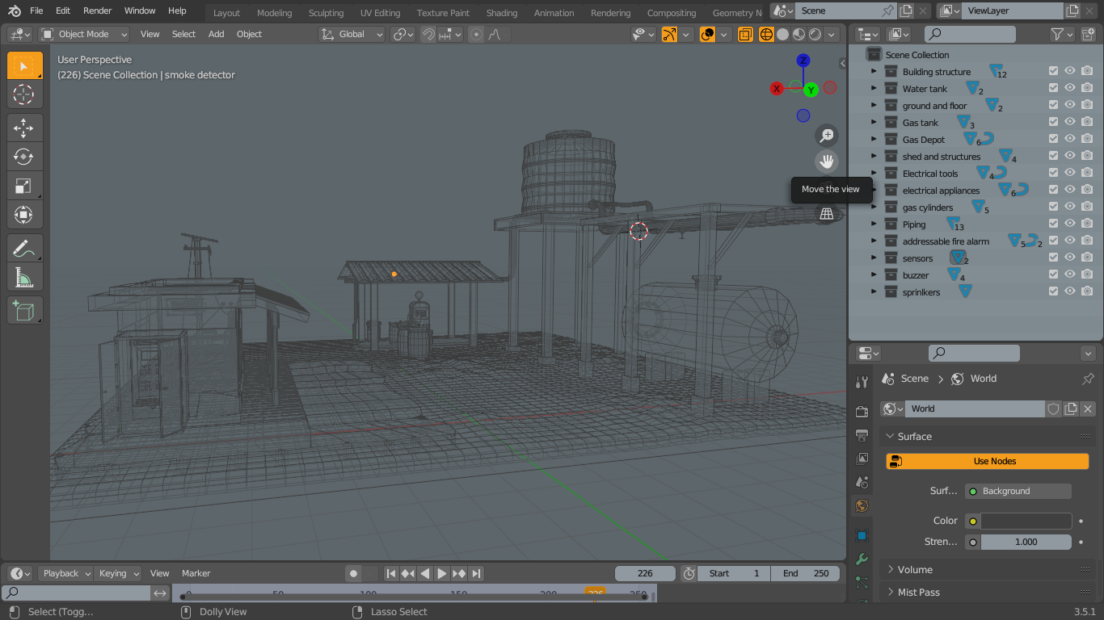

Figure 7. Mesh end view

Figure 7 shows the mesh design of the model. A typical local sales station was modeled to illustrate the application of our system. The shows the end view of the sales station.

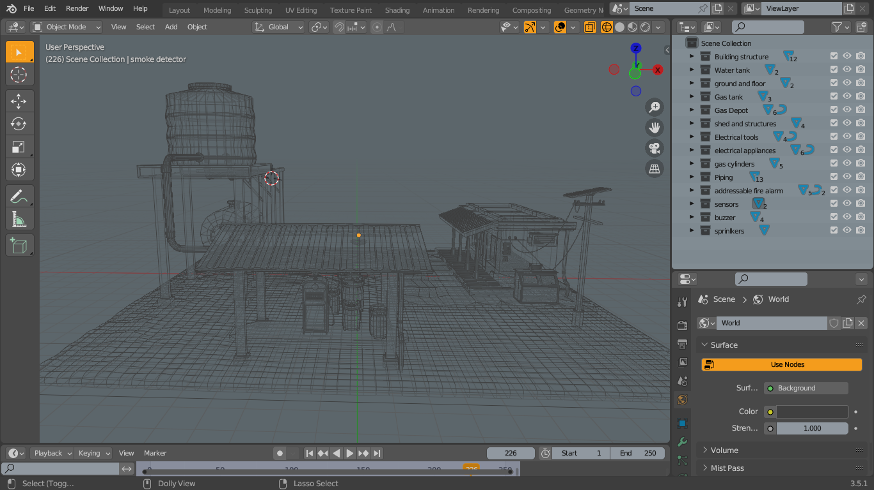

Figure 8. Mesh front view

The front mesh view of the sales station is displayed in figure 8.

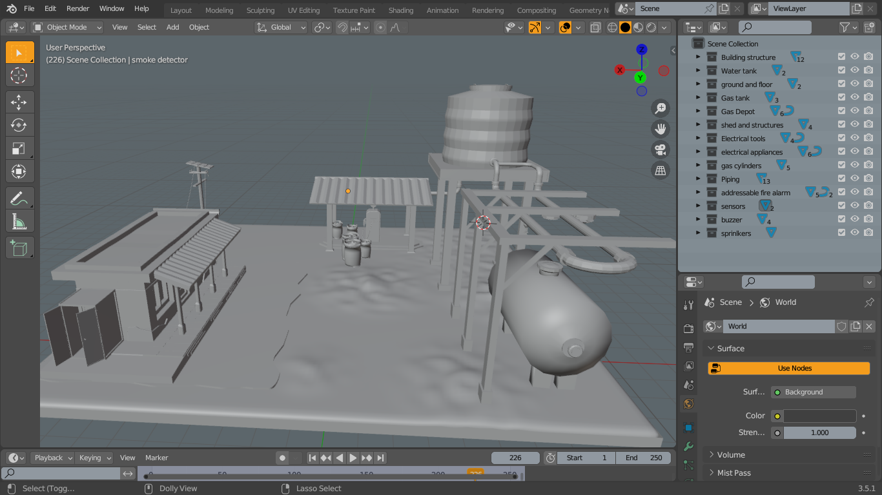

Figure 9. Solid end view

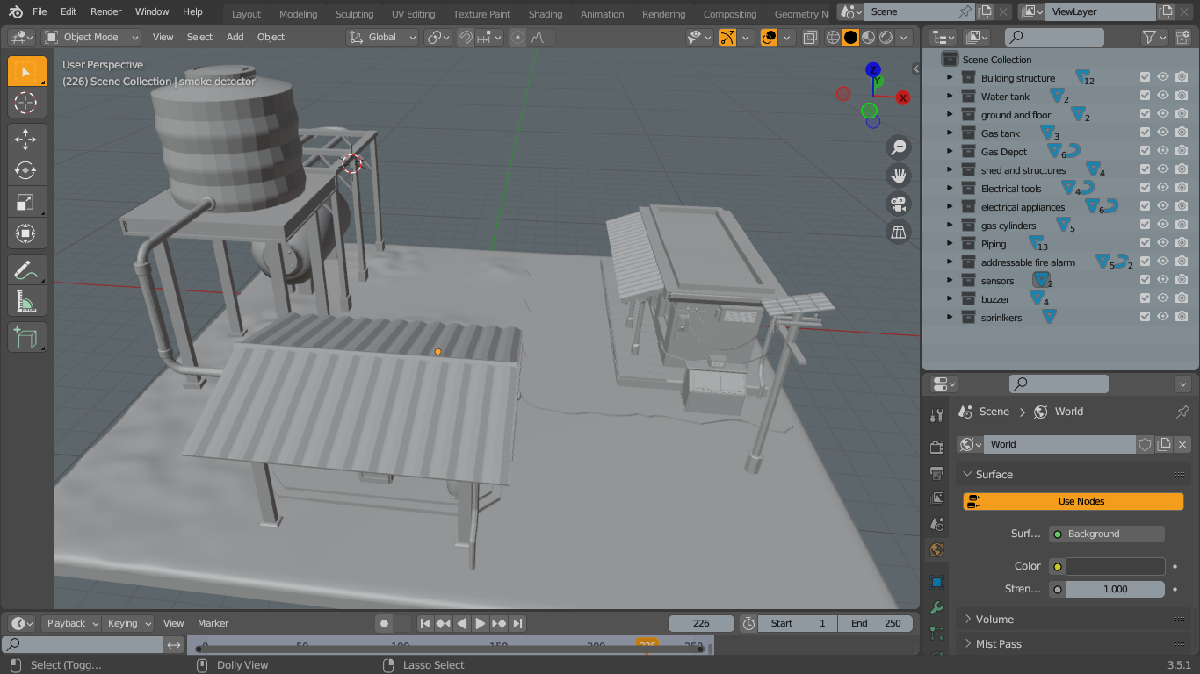

Figure 10. Solid front view

Figures 9 and 10 shows the solid structure of the project simulation.



Figure 11. Addressable fire alarm

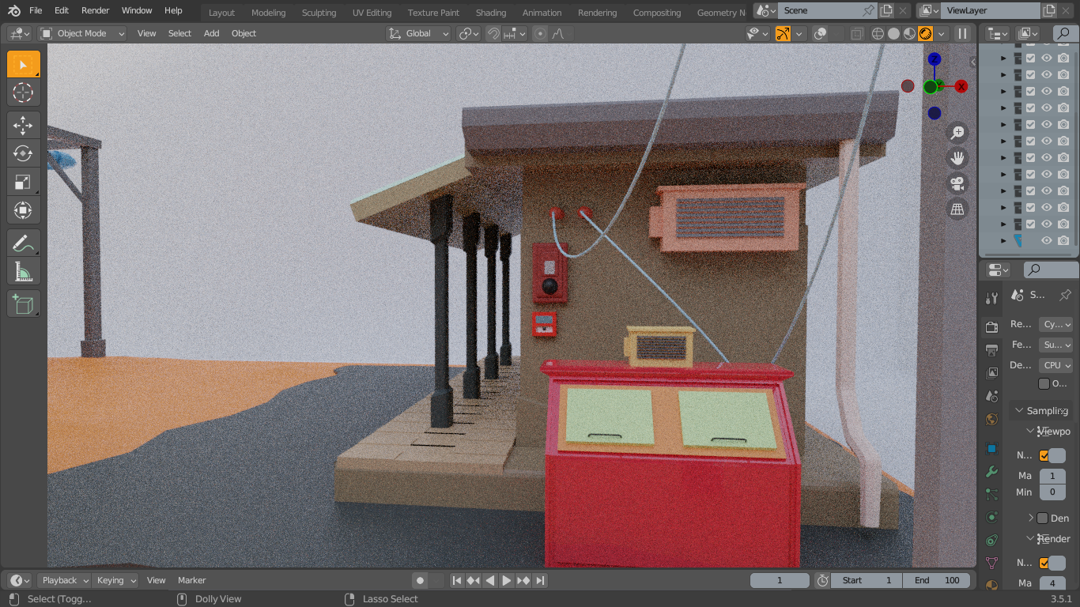

Figure 12. Electrical connections



Figure 13. Gas depot side view 1

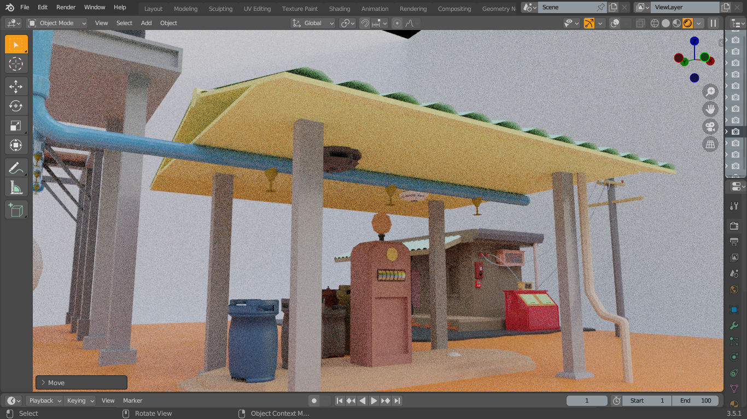

Figure 14. Gas depot side view 2

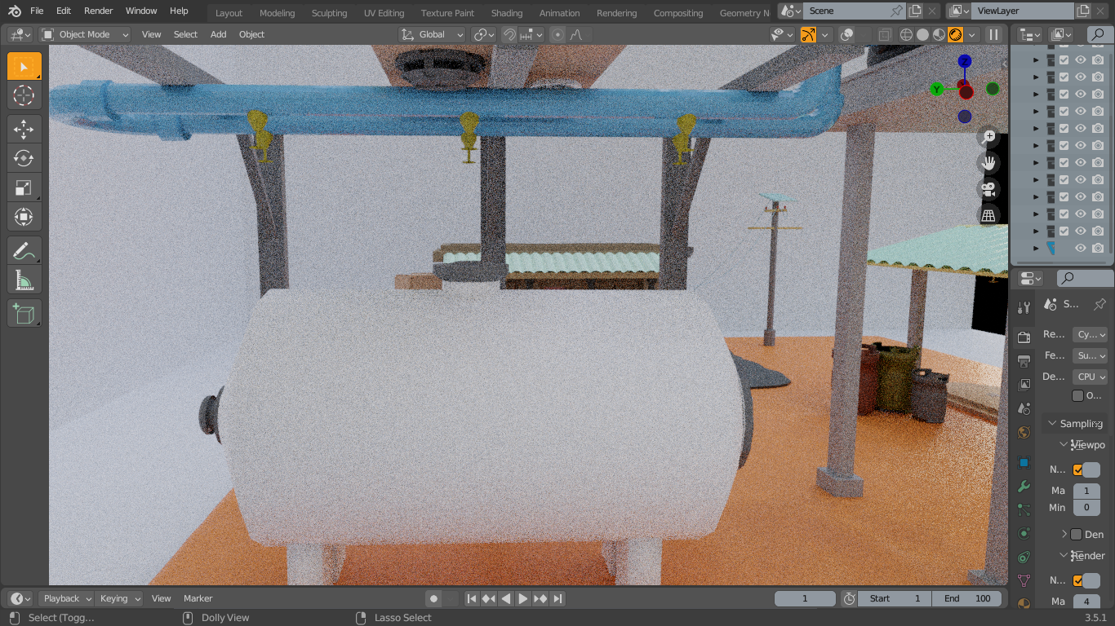

Figure 15. Gas storage tank view

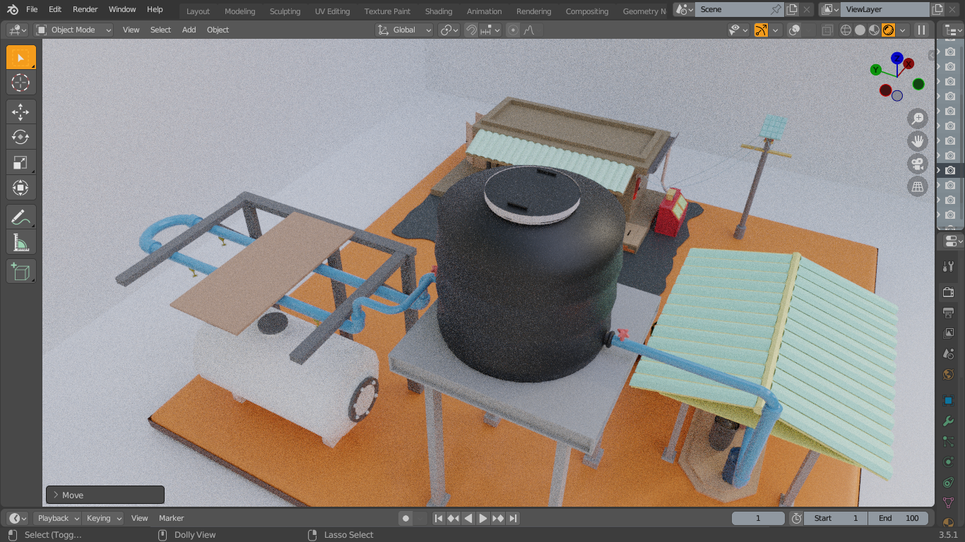

Figure 16. Water tank view

Figures 11 to 16 shows the various views of the system installation around the gas sales station. All the elements which were mentioned in previous chapters are shown in full display in the figure descriptions. The arrangement and placement of every component and structure are to scale.

The image below shows the complete appearance of the sales station and system when rendered.

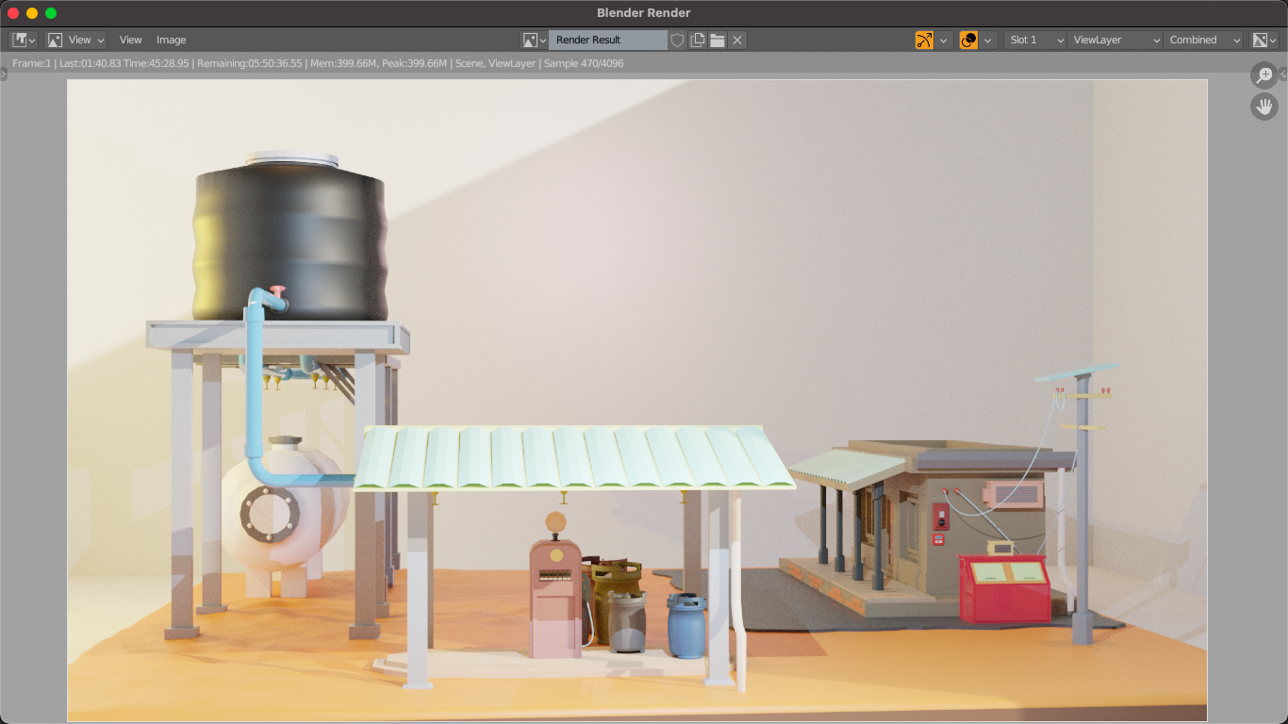

Figure 17. Gas sales station

**4.6 SUMMARY**

This chapter discusses the system designs and system implementation for our proposed system. This chapter gives an overview of how the proposed system was designed in relation to both the logical and physical design and how it was implemented.

**CHAPTER FIVE**

**SUMMARY, CONCLUSION AND RECOMMENDATION**

**5.1 SUMMARY**

In chapter one, we talked about the background study of LPG gas and its composition, problems situated with the use of LPG gas and the particular problem we intend to solve, the aims and objectives of the project, the importance and the project scope of work as well as some of the limitations of the project.

Chapter two focused on gas explosions in Accra and Kumasi and the research we conducted on the handling, transportation and consumption of the LPG which we gathered from the National Fire Service Ghana.

Chapter focused on the proposed solution by the introduction of our system, the current systems, review of the current systems, the challenges and limitations of the current system and the advantages of our proposed system.

In chapter four, we delved into how the data was collected and analyzed. We further discussed the system design and the implementation of the whole project. This chapter gives a full overview of how the system was designed, the logic behind it and its implementation.

The idea behind the project was to design a system that would be able to fight fires that occur at LPG sales station. To do this, we had to pay attention to previous gas explosions and also speculate fires at possible areas within the sales station.

We successfully modeled the system we proposed and its operation. In view of this, it is important to note that safety at the LPG sales station is highly recommended and must not be overlooked in any case. Gas sales personnel are to undergo training and guidance to avoid accidents or reduce the rate of accidents.

**5.2 CONCLUSION**

In conclusion, the goals of this project were achieved. Our project simulation was tested and it worked as planned. The project simulation video which is in the attached document shows the process of operation.

In the development, we faced some issues. Data findings was hard to come buy because some sites had less details of the information we needed. In the design process, we had issues in the design process. Scaling of the sales station from the ground to the software was going out of scale as we added more infrastructure. But we resolved it. Rendering of the simulation was also taking more hours almost entering a day. We had to reduce the bit rate which also decreased the resolution.

**5.3 RECOMMENDATION**

This automatic fire prevention and fighting system by its design details, would quickly respond to any fire that might start at the LPG sales station. There would not be a case where;

1. There would not be any water shortage to fight any fire as enough water would be in the overhead tank.
2. No power outage can disrupt water flow from the tank as the means of water flow is through gravity.

It is therefore recommended that this automatic fire prevention fighting system should be installed at all LPG sales stations.

**REFERENCES**

|  |  |
| --- | --- |
| [1] | "Ghana gas explosion 'kills five' in Accra," [Online]. Available: https://www.bbc.com/news/world-africa-38416186#:~:text=NPA%20head%20Moses%20Asaga%20told,site%20and%20caused%20the%20fire.. |
| [2] | "How a citizen journalist predicted a possible gas explosion at Atomic Junction," GhanaWeb, [Online]. Available: https://www.ghanaweb.com/GhanaHomePage/NewsArchive/How-a-citizen-journalist-predicted-a-possible-gas-explosion-at-Atomic-Junction-588926. |
| [3] | "Crisis meeting over gas explosion in Kumasi," MyJoyOnline, [Online]. Available: https://www.myjoyonline.com/crisis-meeting-over-gas-explosion-in-kumasi/?myjo-------https://www.myjoyonline.com/crisis-meeting-over-gas-explosion-in-kumasi/-------https://www.myjoyonline.com/crisis-meeting-over-gas-explosion-in-kumasi/-------https://www.m. |
| [4] | M. Z. Khama, "THE LPG MARKET IN GHANA, POTENTIALS AND CHALLENGES. Mohammed Zakiw Khama," [Online]. Available: https://www.linkedin.com/pulse/lpg-market-ghana-potentials-challenges-mohammed-zakiw-zakiw-khama. |
| [5] | M. Z. Khama, "THE LPG MARKET IN GHANA, POTENTIALS AND CHALLENGES. Mohammed Zakiw Khama," [Online]. Available: https://www.linkedin.com/pulse/lpg-market-ghana-potentials-challenges-mohammed-zakiw-zakiw-khama. |
| [6] | M. Z. Khama, "THE LPG MARKET IN GHANA, POTENTIALS AND CHALLENGES. Mohammed Zakiw Khama," [Online]. Available: https://www.linkedin.com/pulse/lpg-market-ghana-potentials-challenges-mohammed-zakiw-zakiw-khama. |
| [7] | M. Z. K. Mohammed, "THE LPG MARKET IN GHANA, POTENTIALS AND CHALLENGES. Mohammed Zakiw Khama," [Online]. Available: https://www.linkedin.com/pulse/lpg-market-ghana-potentials-challenges-mohammed-zakiw-zakiw-khama. |
| [8] | M. S. N. D. K. Priya, "SMART GAS CYLINDER USING EMBEDDED SYSTEM," 2014. [Online]. Available: https://www.semanticscholar.org/paper/SMART-GAS-CYLINDER-USING-EMBEDDED-SYSTEM-Priya-Surekha/d9036fad09902ff8d43fbb566b9d100ac8718ec1. |
| [9] | H. S. ,. M. A. Khyati Bhargava, "Gas Leakage Detection and Prevention," 2016. [Online]. Available: https://ijesrr.org/publication/31/IJESRR%20V-3-2-15.pdf. |
| [10] | M. M. Khan, "Sensor-Based Gas Leakage Detector System," [Online]. Available: https://www.mdpi.com/2673-4591/2/1/28. |